Making ajax (internet)

* Te_sf_update.jsp



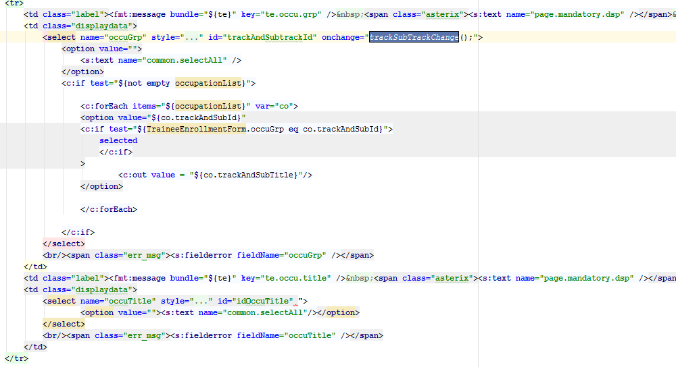

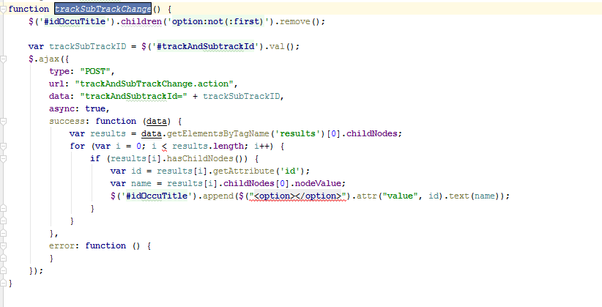

* Strut.xml

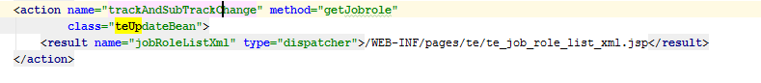

* TeUpdateAction.java

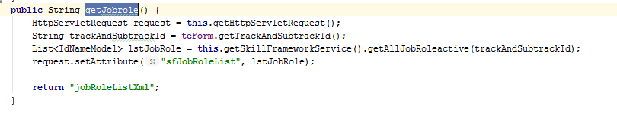

* Te_job_role_list_xml.jsp

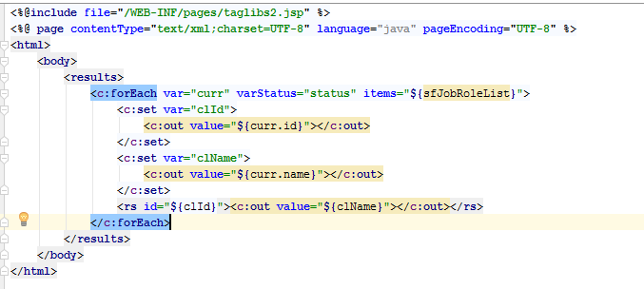

* Securityfifle

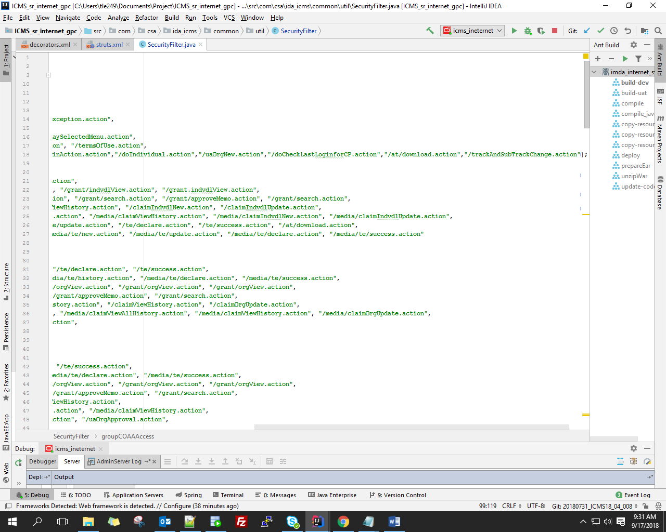

* Decorator.xml

